CUSTOMER SEGMENTATION USING K-MEANS CLUSTERING
Week 3 Task: Unsupervised Learning and Clustering Analysis
1. Abstract
Customer segmentation is an important application of unsupervised machine learning that enables organizations to identify groups of customers with similar characteristics. This project applies K-Means clustering to a publicly available Mall Customer Segmentation dataset to discover meaningful customer groups based on annual income and spending score. Unlike supervised learning, clustering does not require predefined target labels. Instead, the algorithm identifies natural groupings within the data based on similarity.
The project begins with data loading and exploratory inspection using Python and Pandas. The dataset is checked for missing values, data types, and basic statistical properties. Annual Income and Spending Score are selected as the principal clustering features because they provide a meaningful representation of customers' financial capacity and purchasing behavior. The selected variables are standardized using StandardScaler to ensure that differences in feature scales do not disproportionately affect the clustering process.
K-Means clustering is then implemented using Scikit-learn. The Elbow Method is used to examine different values of K and determine an appropriate number of clusters. Silhouette Score is also calculated to evaluate the quality of the resulting segmentation. The final clusters are visualized using a scatter plot, and the mean characteristics of each cluster are analyzed.
The analysis demonstrates how unsupervised learning can transform raw customer information into meaningful segments. These segments can support customer profiling, targeted marketing, personalized promotions, customer retention strategies, and business decision-making. The project also discusses the limitations of K-Means and possible improvements using alternative clustering techniques.

2. Introduction
Organizations collect large amounts of customer information through transactions, registrations, surveys, and digital interactions. However, simply storing customer information does not automatically provide useful business insights. Customer segmentation is a technique used to divide customers into groups according to similarities in their characteristics or behavior.
Machine learning provides several approaches for customer segmentation. In particular, unsupervised learning is useful when predefined categories are not available. Clustering algorithms automatically identify groups of similar observations.
This project uses K-Means clustering to analyze mall customer data. The primary objective is to determine whether customers can be separated into meaningful groups according to annual income and spending score.
The project demonstrates a complete basic unsupervised learning workflow, including data inspection, preprocessing, feature selection, clustering, model evaluation, visualization, and interpretation.

3. Problem Statement
Retail businesses may have customers with substantially different income levels and purchasing behaviors. Treating all customers identically can make marketing activities less targeted.
The problem addressed in this project is:
"Can customers be grouped into meaningful segments based on their annual income and spending score using an unsupervised machine learning algorithm?"

4. Objectives
The main objectives are:
- To select and analyze a publicly available customer dataset.
- To understand the characteristics of the dataset.
- To preprocess the data for clustering.
- To apply the K-Means clustering algorithm.
- To determine an appropriate number of clusters.
- To evaluate cluster quality using Silhouette Score.
- To visualize the resulting customer segments.
- To interpret the characteristics of each cluster.
- To identify potential business applications of customer segmentation.
- To understand the practical limitations of K-Means clustering.

5. Dataset Description
The Mall Customer Segmentation dataset contains customer-level information.
Important variables include:
Variable | Description
CustomerID | Unique customer identifier
Gender | Customer gender
Age | Customer age
Annual Income (k$) | Approximate annual income
Spending Score (1-100) | Spending score assigned to the customer
For clustering, the following two variables are selected:
- Annual Income (k$)
- Spending Score (1-100)
These variables are selected because they provide a straightforward representation of customers' financial capacity and spending behavior.

6. Technologies and Libraries
The project uses Python and the following libraries:
- Pandas – data manipulation
- NumPy – numerical operations
- Matplotlib – visualization
- Scikit-learn – preprocessing, clustering, and evaluation

7. Data Preprocessing
The dataset is first loaded using Pandas. The first few records are examined to understand the structure of the data.
Missing values are checked using:
df.isnull().sum()
The selected clustering variables are:
X = df[['Annual Income (k$)', 'Spending Score (1-100)']]
Since clustering is sensitive to feature scales, StandardScaler is used.
from sklearn.preprocessing import StandardScaler

scaler = StandardScaler()
X_scaled = scaler.fit_transform(X)
Standardization transforms the variables so that they have comparable scales. This prevents a variable with a larger numerical range from dominating the distance calculations used by K-Means.

8. Methodology
8.1 K-Means Clustering
K-Means is an unsupervised learning algorithm that partitions observations into K clusters.
The algorithm works through the following basic steps:
- Select the number of clusters K.
- Initialize K centroids.
- Assign each observation to the nearest centroid.
- Recalculate centroid positions.
- Repeat the assignment and centroid update steps.
- Continue until the clusters stabilize.
The objective of K-Means is to minimize the within-cluster sum of squared distances.

9. Selection of Number of Clusters
Selecting an appropriate value of K is an important part of K-Means clustering.
Elbow Method
The Elbow Method calculates the model's inertia for different values of K.
inertia = []

for k in range(2, 11):
kmeans = KMeans(
n_clusters=k,
random_state=42,
n_init=10
)
kmeans.fit(X_scaled)
inertia.append(kmeans.inertia_)
The inertia values are plotted against the number of clusters.
Figure 1: Elbow Method
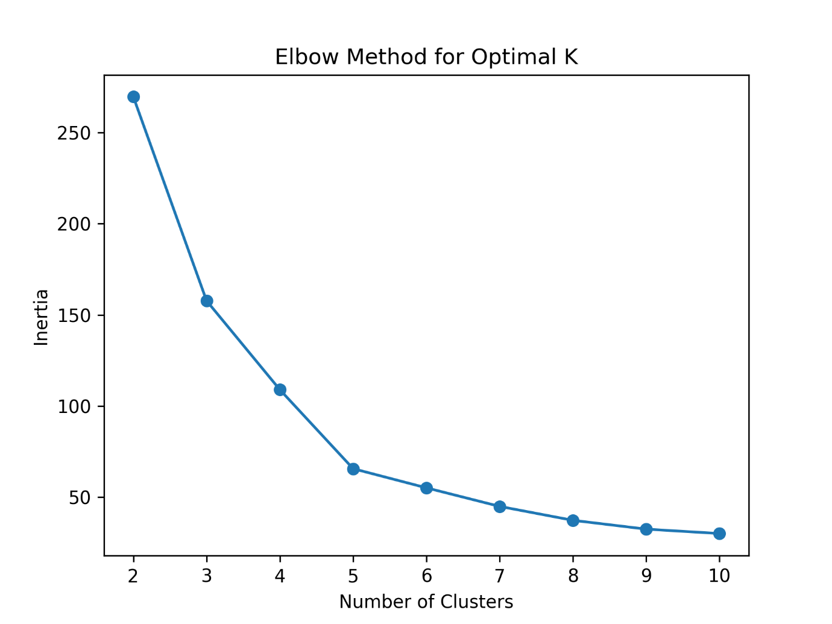The graph should be examined for a point where increasing the number of clusters produces diminishing improvements in inertia. In this project, K=5 is used for the final segmentation because it provides a useful and interpretable segmentation of the customer data.

10. Model Implementation
The final K-Means model is created using five clusters.
kmeans = KMeans(
n_clusters=5,
random_state=42,
n_init=10
)

df['Cluster'] = kmeans.fit_predict(X_scaled)
The random_state parameter makes the experiment reproducible, while n_init=10 performs multiple centroid initializations to improve the reliability of the solution.

11. Silhouette Score
Silhouette Score measures how well observations fit within their assigned clusters compared with other clusters.
from sklearn.metrics import silhouette_score

score = silhouette_score(
X_scaled,
df['Cluster']
)

print("Silhouette Score:", score)
Obtained Silhouette Score:
[INSERT ACTUAL SILHOUETTE SCORE]
A higher Silhouette Score generally indicates better separation between clusters, although the appropriate interpretation depends on the dataset and application.

12. Cluster Visualization
The resulting clusters are visualized using Annual Income and Spending Score.
plt.scatter(
df['Annual Income (k$)'],
df['Spending Score (1-100)'],
c=df['Cluster']
)

plt.xlabel("Annual Income (k$)")
plt.ylabel("Spending Score (1-100)")
plt.title("Customer Segmentation using K-Means")
Figure 2: Customer Segmentation
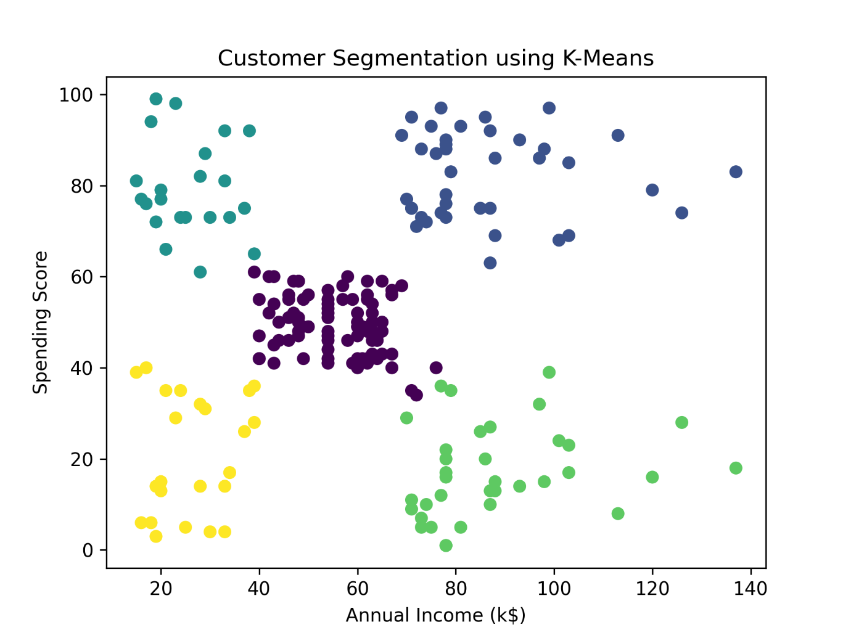
The visualization demonstrates that customers can be separated into groups based on the relationship between income and spending score.

13. Cluster Characteristics
The average characteristics of each cluster are calculated using:
df.groupby('Cluster')[
['Age', 'Annual Income (k$)', 'Spending Score (1-100)']
].mean()
Cluster Analysis
Cluster 0:
This cluster represents customers with relatively low-to-moderate income and spending levels. These customers may have lower purchasing activity compared with high-spending groups.
Cluster 1:
This segment contains customers with relatively high income and high spending scores. From a descriptive perspective, these customers represent a high-value spending segment.
Cluster 2:
This cluster is characterized by lower income combined with relatively high spending scores. Such customers demonstrate relatively high spending despite lower income.
Cluster 3:
This segment contains customers with higher income but comparatively lower spending scores. This group may represent an opportunity for further customer engagement, although additional behavioral data would be necessary to understand the reasons behind the spending pattern.
Cluster 4:
This group generally represents customers with moderate income and moderate spending behavior.
The exact numerical averages should be reported using the output generated by the Python program.

14. Business Implications
Customer segmentation can be useful for several business activities.
Targeted Marketing
Different customer segments can receive different promotional messages rather than receiving identical campaigns.
Personalized Offers
Customers with higher spending scores could potentially receive loyalty benefits, while lower-engagement customers could receive introductory promotions.
Customer Retention
Segment-level analysis can help businesses identify groups that require additional engagement.
Resource Allocation
Marketing resources can be allocated according to customer segment characteristics.
Product Strategy
Different customer groups may respond differently to products, discounts, and promotional campaigns.
These are potential applications; actual effectiveness would need to be tested using additional business data.

15. Advantages of K-Means
- Simple and easy to understand.
- Computationally efficient for small and medium-sized datasets.
- Easy to implement using Scikit-learn.
- Produces interpretable clusters.
- Suitable for exploratory customer segmentation.
- Cluster results can be visualized effectively.

16. Limitations
- The number of clusters must be selected in advance.
- K-Means is sensitive to initialization.
- Outliers can influence cluster centroids.
- It generally works best when clusters have relatively compact shapes.
- Results depend on the selected features.
- Two features cannot capture every aspect of customer behavior.
- Customer segments should not automatically be interpreted as fixed behavioral categories.

17. Future Improvements
Future work could include:
- Hierarchical clustering.
- DBSCAN clustering.
- Additional customer features.
- Transaction-level purchasing information.
- Customer lifetime value.
- Purchase frequency.
- Product preferences.
- Dimensionality reduction using PCA.
- Comparison of multiple clustering algorithms.

18. Conclusion
This project demonstrated the application of unsupervised learning for customer segmentation using K-Means clustering.

